Spearheadcluster ENT. A // Template two-pager – innovation trajectory
We ask the submitter to adhere to the word limits when filling in this template. Two-pagers that exceed these may be declared inadmissible.
- Name of submitting company or organization and SPOC (name, email and telephone number):

- Please provide a brief summary of the project idea that may be shared with other ENT. A members in function of the observatory. Only this summary will be shared and the SPOC, not the full 2-pager and the rest of consortium.
Briefly summarize the project idea (up to 10 lines).
  - Which keywords (tags) apply to this project?
☐ Event | ☐ Media | ☐ AI | ☐ Gaming tech | ☐ XR
☐ Gaming | ☐ Cultural and creative sectors | ☐ Compute Connectivity | ☐ Sensing | ☐ Data-innovation
  - Which partners are you still looking for, or would be welcome, to further shape this project idea together?
It is important to indicate which types of partners you may still need to further develop your project idea. This may include organisations or research groups with specific expertise, access to particular knowledge domains, or complementary experience that can strengthen your project. By formulating this clearly, the ENT.A network can search more effectively for suitable partners. Only the short summary is shared with all members, but your specific partner requirements help determine which parties are the best fit for your project.
- Define the innovation/knowledge leap to be achieved
Describe the extent to which the project leads to a substantial innovation or breakthrough compared to the current state of technology, processes or applications within the sector. Indicate the distinctive character of the innovation, how big the step forward is compared to existing solutions, and in what time frame this innovation leap can be realized. Explain to what extent the results guide future developments and how they can form a catalyst for further innovation within and outside the cluster. (MAX 300 WORDS).
- Describe the economic and social impact of the project idea
  - Economic impact
Describe the extent to which the project results generate economic return for the consortium (e.g. employment, turnover,...), transcend the consortium involved and are also useful for other companies/organisations within the target group(s) of the cluster. Mention in two sentences what the economic effect may be for your company/organization. Indicate when knowledge sharing and collaboration with other companies within (and outside) the cluster is possible and to what extent the (generic) project results can be used for broader communication (MAX 300 WORDS).
  - Impact on society
Describe the extent to which the project results contribute to societal challenges and benefit the wider public. Indicate the period in which the results will be visible or noticeable to society and to what extent the results of the project can be (generically) applicable in other contexts or sectors. Explain how the results can contribute to themes such as sustainability, inclusiveness, health, mobility or digitalisation, and to what extent knowledge sharing and cooperation with civil society organisations, governments or citizens is envisaged. (MAX 300 WORDS).
- Situate the project idea within ENT's long-term vision. A vzw
Describe the extent to which the project contributes to the realisation of ENT's specific long-term vision. A vzw. Indicate to what extent the project objectives respond to the identified needs/needs/opportunities/opportunities and how the project objectives (if they can be achieved) can effectively make an important contribution to the achievement of the long-term objectives (MAX 500 WORDS).
- If already known, which VLAIO instrument fits the submitted project proposal?
- At ENT. A 7 different VLAIO instruments for which dossiers can be submitted. Collective feasibility studies, collective research projects, collective development projects, ICON projects, TETRA projects, COOCK+ projects and Cluster SBO projects. Companies can act as lead submitters in feasibility studies, research projects, development projects and ICON projects. Knowledge institutions can act as main applicants for ICON projects, TETRA projects, COOCK+ projects and cSBO projects. We realize that this is complex information. More information about this can be found via this link (https://www.vlaio.be/nl/vlaio-netwerk/projecten-voor-speerpuntclusters/aanvraagprocedure-projecten-voor-speerpuntclusters) or you can send an email to jelle.demanet@entertainmentassociatie.be.

- Cluster projects that fit within the instruments: Research Project, Development Project, Feasibility Study and ICON, require collaboration with at least three independent companies that have at least an Inform&Connect membership with ENT. A and two of which can receive VLAIO funding. The main submitter of the two-pager must be a company that has at least an Innovate membership.

- Cluster projects that fit within the instruments TETRA, COOCK+, cSBO and ICON require collaboration with at least three research groups/knowledge institutions that have at least an Innovate membership and of which at least 2 are part of a Flemish research institution. Steering committee members and members of the supervisory group do not need to be a member of ENT. A.

- Mention the consortium of the project and briefly outline the expertise and role of each partner.
- It is important that you are already in consultation with the companies or organizations you mention in the table below before submitting the two-pager.
- In separate paragraphs after the tables, briefly describe the expertise of each partner and what the role of the partner will be within the project (max. 200 words per partner).

Partners who are not knowledge institutions
Company/organization | Company number | Contact | Email

Partners who are knowledge institutions
Organization | Research group/Department | Contact | Email

Steering committee members (only for instruments that require a steering committee)
Company/organization | Company number | Contact | Email

FYI
Submit: Send this two-pager to: info@entertainmentassociatie.be. Learn more about ENT. A can be found on www.entertainmentassociatie.be
Roadmaps
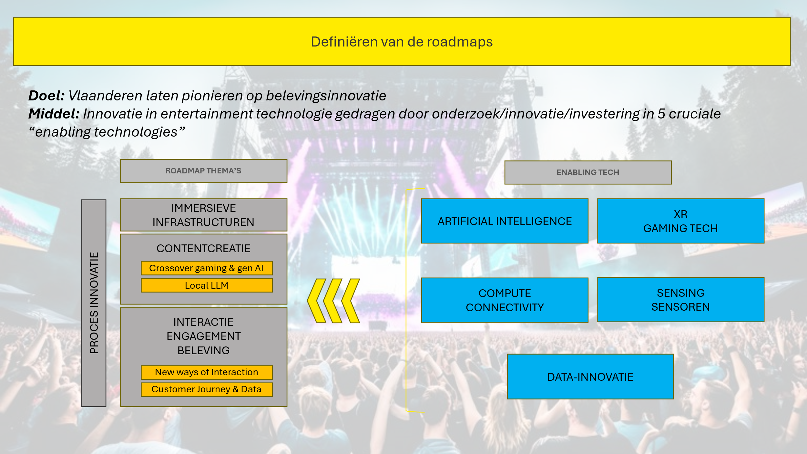
Purpose of the two-pager
The purpose of this two-pager is to give the Innovation Council a first insight into the project idea. The two-pager is a first document in which an idea phase is explored and converted into a possible project application that can be used for the use of the earmarked resources.
Guarantee of confidentiality
After submission of this two-pager, the confidentiality of both the content and the composition of the consortium is guaranteed. Only the summary can be shared with the members of ENT.A. The full document will be handled exclusively by the project secretariat and will be used exclusively for the preparation of the deliberations of the Innovation Council. The project secretariat is bound to confidentiality and will not provide any information from this document to third parties, except to the extent strictly necessary for the performance of its tasks.
The Innovation Council and the Council of Knowledge Institutes are bound by the internal regulations to a duty of confidentiality with regard to all two-pagers that are submitted in the context of its work. This means that the members of the Innovation Council and the Council of the Knowledge Institutions, as well as any advisors or third parties who obtain access to the content on behalf of the Innovation Council, are obliged to treat the information received confidentially, not to reproduce or disseminate, and to use it only within the context of the decision-making for which it was provided.

